**myUoM User Manual**



**Created by Open Source UoM https://opensource.uom.gr**

Thessaloniki August 2022

**CONTENTS**

**Introduction and How to Use 3 What is UoM 4 How to Navigate 4 Settings 6 Course Schedules Tile 6 Open eClass Tile 6 StudentsWeb Tile 6 Eudoxus Tile 7 Restaurant Tile 7 Library Tile 7 Student Care Tile 7 Other Services Tile 7 Inauguration Tile 8 Freshmen Tile 8 Map Tile 8 Academic Personnel Tile 8**

Introduction and How to Use

myUoM is a project of the Open Source Group of Applied Informatics of the University of Macedonia (http://opensource.uom.gr). It has been built to assist students in their daily interaction with the University.

The application can be accessed from all types of devices. You can access it from your computer using the browser via https://my.uom.gr. From your mobile, you can open the browser or you can save an icon to the home screen. To do this, you need to tap on the top right of the 3 dots and find the Add to Home Screen option. (or, the Install App option)

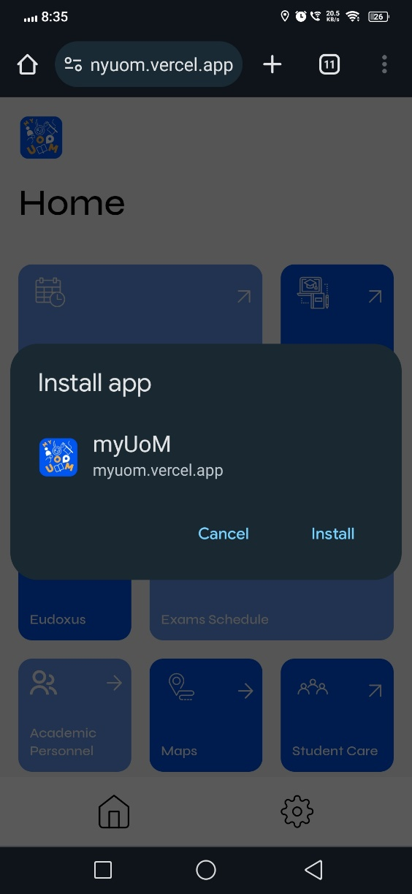

Add shortcut screens

**Please note that you must have an internet connection to use the application.**

**Before using the application, please read the release notes and user manual.**

If you have a question about using the application, please send an e-mail to linux-team@uom.edu.gr

The app comes under an MIT license.

What is myUoM

myUoM is a mobile and computer application where students can find information about the teaching schedule, the exam schedule, view grades on the StudentsWeb, access the Eudoxus system to request the books of the current semester, but also have access to library services. They can also be informed about the restaurant's menu and have access to services that are not so prominent on the website.

HOW TO NAVIGATE

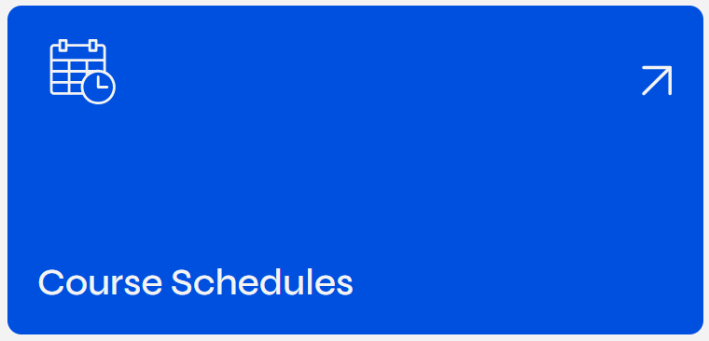

Tile

By tapping on a tile, you can navigate through the app. The arrows indicate that this tile will navigate within the app (Straight) or go to a link outside the app (Diagonally Up).



Arrow (Straight)



Arrow (Diagonally up)

In the first case, you will be navigated within the application to one of the tiles explained below. In the second case, a new window will open that you can navigate, and you will remain on the same page.

There are 3 ways to go back to the homepage. If you're on a computer, tap either the logo (top left) or the left arrow (top left).



Logo, Arrow to return on computer

If you are on a mobile or tablet, click either on the arrow pointing to the left (located on the top right) or on the option with the Little House icon in the Navigation Bar at the bottom of the screen.

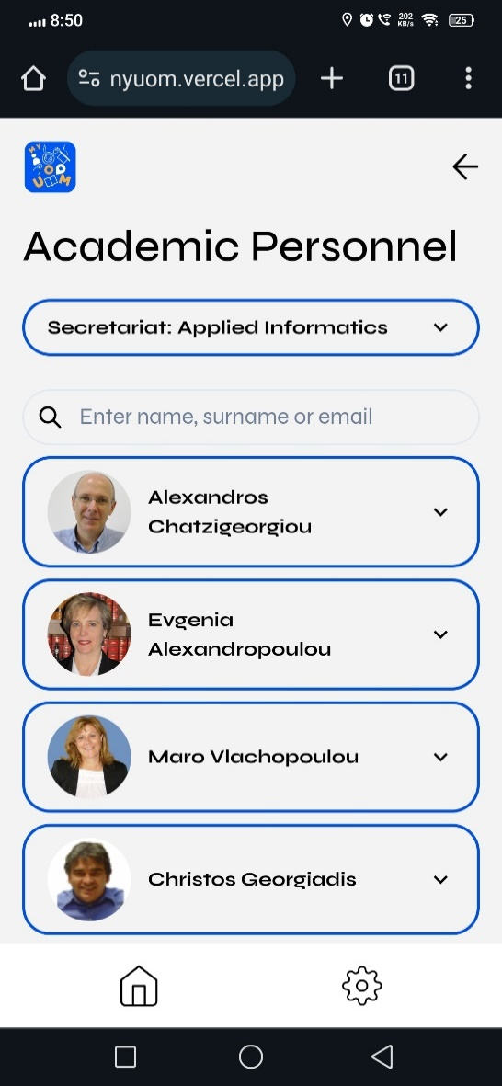

Logo, Arrow to return on mobiles and tablets

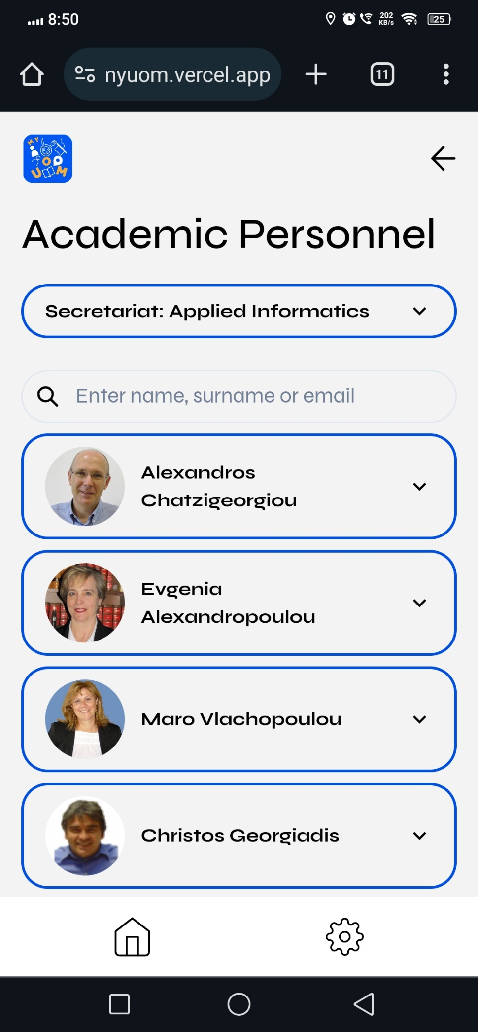

Bottom navigation bar on mobiles and tablets

In the gear you will find various settings and information that you will need to personalize the application, such as dark theme or segment selection. **CAUTION: If navigating with your browser, you must allow pop-ups to appear.**

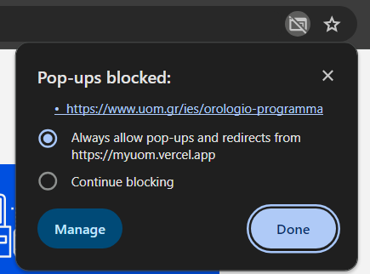

SETTINGS

In the settings you will find the segment option. This option will be saved locally in the browser on your computer or in the application installed on your mobile. This is the only "**personal**" information the app stores about you. You will notice that if you do not select your school, some tiles are inactive and you cannot select them.

If you prefer dark theme, you can activate the option by dragging the switch. On our FAQ page, you'll find some questions and answers that can help you navigate the app. On the About page you will find some information about the application, the application development team as well as the social media of the Open Source team. In the license you can read the full MIT license in English. Finally, if you liked the app and found it useful, let your friends know to use it too, but you can also contribute to the app through our Gitlab repository, as long as the app is Open Source. The help does not necessarily have to be in the programming part, but in matters of translation or correction of spelling errors.

To close the settings window, press the X at the bottom.

LESSON SCHEDULE TILE

By clicking on the course schedule, once you have chosen which school you are in, you will be moved to an external window containing your school's curriculum. Note in this publication, the program is provided by an external link. We encourage you to consult it daily for any changes. In future editions we hope to make it more personalized and the update to be done automatically.

OPEN ECLASS TILE

Clicking on the Open eClass tile will take you to an external window on the Open eClass page to enter your username and password and access the portfolio of courses you are attending. The application sends you an external link by opening a new browser window. Your credentials are not stored on an application server.

STUDENTSWEB TILE

Clicking on the Student's Web tile will take you to an external window on the StudentsWeb page to enter your username and password and access your transcript, course statements and applications to the secretariat. The app sends you to an external link by opening a new browser window. Your credentials are not stored on an application server.

EUDOXUS TILE

Clicking on the Eudoxus tile will take you to an external window on the Eudoxus page to enter your username and password and access the management of requests for the receipt of your books. The application sends you an external link by opening a new browser window. Your credentials are not stored on an application server.

RESTAURANT TILE

By clicking on the Restaurant tile, you will be taken to the internal page of the Restaurant where the menu will be displayed. The top panel shows the menu served at that time (lunch or dinner). If the hours of dinner have passed, then the next day's menu appears. You can see the hours that the restaurant is open but also see in detail the menu throughout the week.

LIBRARY TILE

By clicking on the Library tile, you will be taken to the internal page of the Library where you will be shown information about the opening hours and the ways of communication. In case you want to search for a book or have an interaction with the library's website, you can click on the button that will go to its website. For some services, you may be asked to enter a username and password. However, you are outside the myUoM app in your default browser, so your credentials are not stored on the app's server.

STUDENT CARE TILE

By clicking on the Student Care tile you will be taken to an external window on the university's website and specifically to Student Welfare to see the latest news and information you may need about food, housing, health care, student housing allowance etc.

OTHER SERVICES TILE

By clicking on the Other Services tile, you will be taken to the internal page that displays all the Services of the University where the student associations, offices and some other services that may be of interest to you are displayed. Navigation is done with the help of tabs. By clicking on a button, you will be taken to an external link on the website of the respective service, association or office.

INAUGURATION TILE

By clicking on the Inauguration tile, if you have selected your school, you will be taken to an external window on the corresponding website with information about the oath-taking procession. Please note that the link may change and not be updated in time, since some secretariats may change it and the person in charge of the application has not been informed.

FRESHMEN TILE

Tapping on the First-year tile will take you to the Information needed page for a first-year student. The information is divided into 3 categories, general concerning academic identity and book sharing service, Eudoxus, registrations on university platforms, and general information on food, housing and healthcare.

MAP TILE

By clicking on the Map tile, you will be prompted to select the building you wish to display and then select the office or room. After selecting them, an image of the map will appear with a red dot informing you where the office or room you selected is located. In case you cannot see the image clearly, you can zoom in. Alternatively, you can also see the virtual tour of the university (you will go to the website of the University of Macedonia where it is available).

ACADEMIC PERSONNEL TILE

By clicking on the Academic Personnel tile, if you have selected a school, you will go to a screen with information about the secretariat of the school you selected and the teachers. There is a search bar where you can search by first name, last name and email. The teacher's title, phone number, email, office, and office building are displayed. At the end of each tab you will find a button that says contact the teacher. Pressing the button will open the email compose directly via Gmail. Attention, you may NOT be logged in with your academic email (if you send from your staff, the professor may not answer you).

**ATTENTION:** In the information, there are no teachers who are contract teachers or EDIP.